University of Missouri

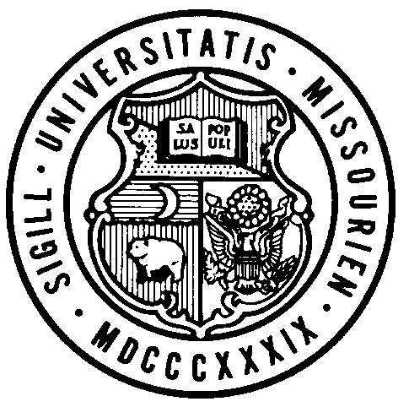
Board of Curators

Special Meeting

Monday, September 13, 2021
4:00 P.M.

Originating:
From remote locations via Zoom and/or conference telephone.

Zoom Webinar Link: https://umsystem.zoom.us/j/99197394966
Webinar ID: 99197394966

Public Session Dial-In Number: +13017158592,,99197394966#

AGENDA

PUBLIC SESSION – 4:00 P.M.

- Call to Order – Roll call of the Board of Curators
- General Business
  - Action
    - COVID-19 Masking Policy
    - Adjourn, Special Board of Curators Meeting, September 13, 2021

